Task 1

To get the Ip address of the domain guvi.in

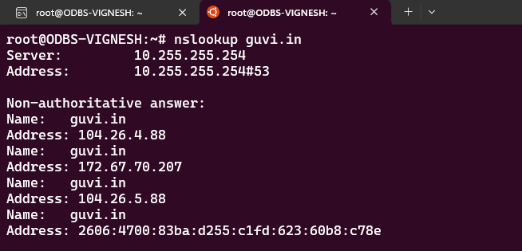

CPU usage

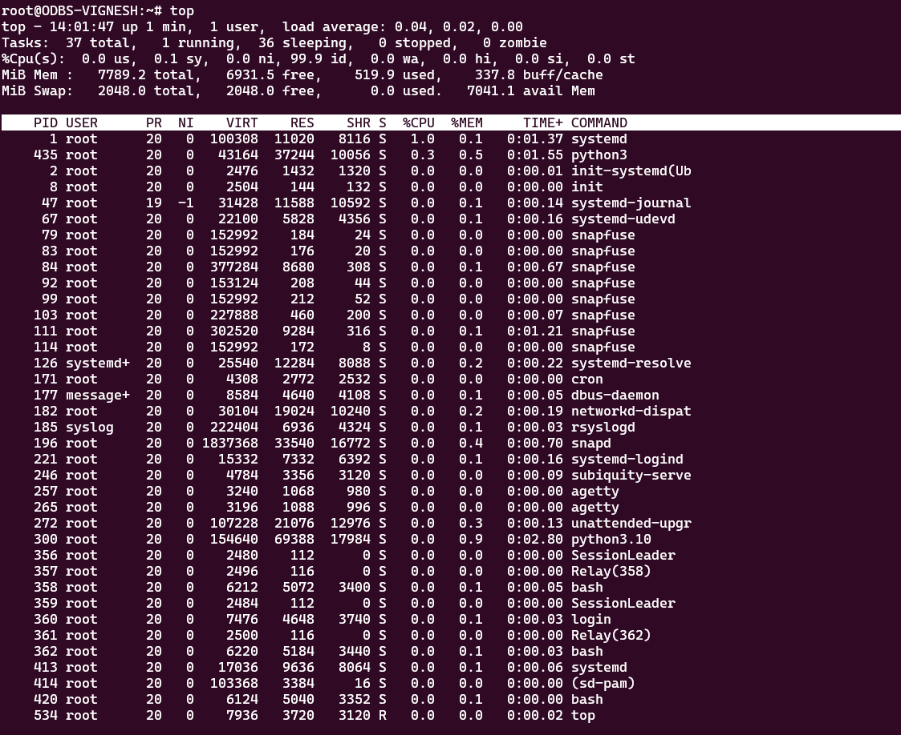

Memory usage

To test the connectivity between two nodes

**Task 2**

Commands:

curl -I <http://guvi.com:9000>

or

nmap -p 9000 guvi.com